Ayesha Zubair
52916
Lab 7

Task 1:

Code:
#include <iostream>
using namespace std;

string input;
int i = 0;

void S() {
if(input[i] == 'a') {
i++;
S();
if(input[i] == 'b') {
i++;
} else {
cout << "Error\n";
exit(0);
}
}

}

int main() {
cout << "Enter string: ";
cin >> input;
S();

if(i == input.length())
cout << "Accepted\n";
else
cout << "Rejected\n";
}

Output:
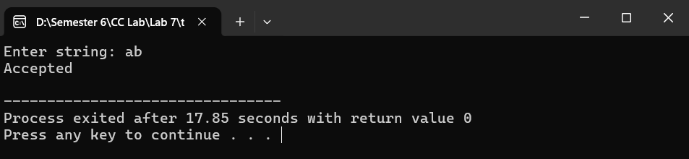

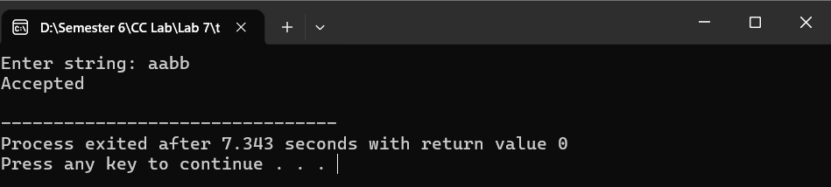

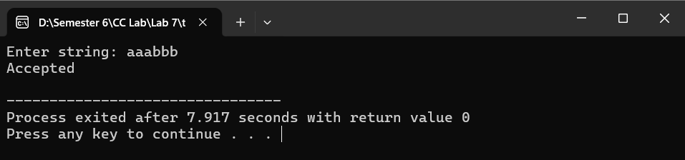
For inputs like ab, aabb, aaabbb, recursion ensures each a is matched with a corresponding b.
Thus, the string is accepted only if the number of a’s equals the number of b’s and they are properly balanced.

Task 2:
Code:
#include <iostream>
using namespace std;

string input;
int i = 0;

void E(), Eprime(), T(), Tprime(), F();

void match(char c) {
if(input[i] == c)
i++;
else {
cout << "Error\n";
exit(0);
}
}

void E() {
T();
Eprime();
}

void Eprime() {
if(input[i] == '-') {
match('-');
T();
Eprime();
}
}

void T() {
F();
Tprime();
}

void Tprime() {
if(input[i] == '*') {
match('*');
F();
Tprime();
}
}

void F() {
if(input[i] == 'i') {
match('i');
}
else if(input[i] == '(') {
match('(');
E();
match(')');
}
else {
cout << "Error\n";
exit(0);
}
}

int main() {
cout << "Enter expression: ";
cin >> input;

E();

if(i == input.length())
cout << "Accepted\n";
else
cout << "Rejected\n";
}

/*
Left recursion
E = T E'
E' = - T E' | e

T = F T'
T' = * F T' | e

F = i | (E)

*/

Output:
Test expression:
id - id * id
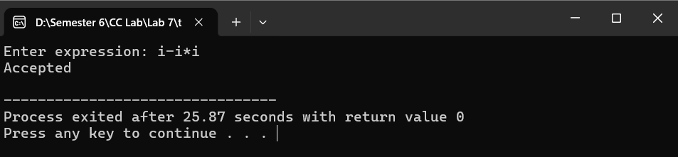

Task 3:
Code:
#include <iostream>
using namespace std;

string input;
int i = 0;

void E(), Eprime(), T(), Tprime(), F();

void match(char c) {
if(input[i] == c)
i++;
else {
cout << "Error\n";
exit(0);
}
}

void E() {
T();
Eprime();
}

void Eprime() {
if(input[i] == '+' || input[i] == '-') {
char op = input[i];
match(op);
T();
Eprime();
}
}

void T() {
F();
Tprime();
}

void Tprime() {
if(input[i] == '*' || input[i] == '/') {
char op = input[i];
match(op);
F();
Tprime();
}
}

void F() {
if(input[i] == 'i') {
match('i');
}
else if(input[i] == '(') {
match('(');
E();
match(')');
}
else {
cout << "Error\n";
exit(0);
}
}

int main() {
cout << "Enter expression: ";
cin >> input;

E();

if(i == input.length())
cout << "Accepted\n";
else
cout << "Rejected\n";
}

Output:
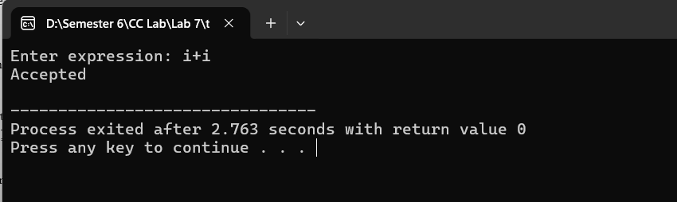
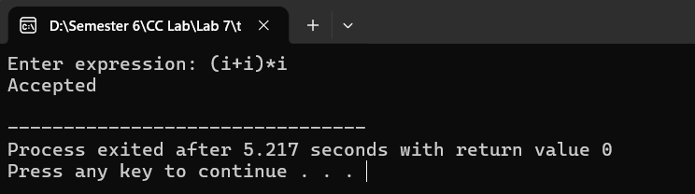
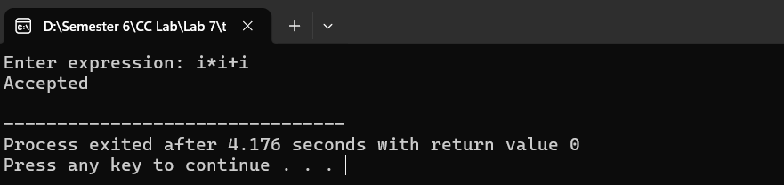

- Parsing starts from E, which calls T first, then E'
- T handles * and /, E' handles + and -
- F matches basic operands (id or (E))
- Recursion processes the expression step-by-step
- Operator precedence is maintained: * , / before + , -
- Expression is accepted if fully matched according to grammar

